PARK GRANGE MEDICAL CENTRE NEWSLETTER

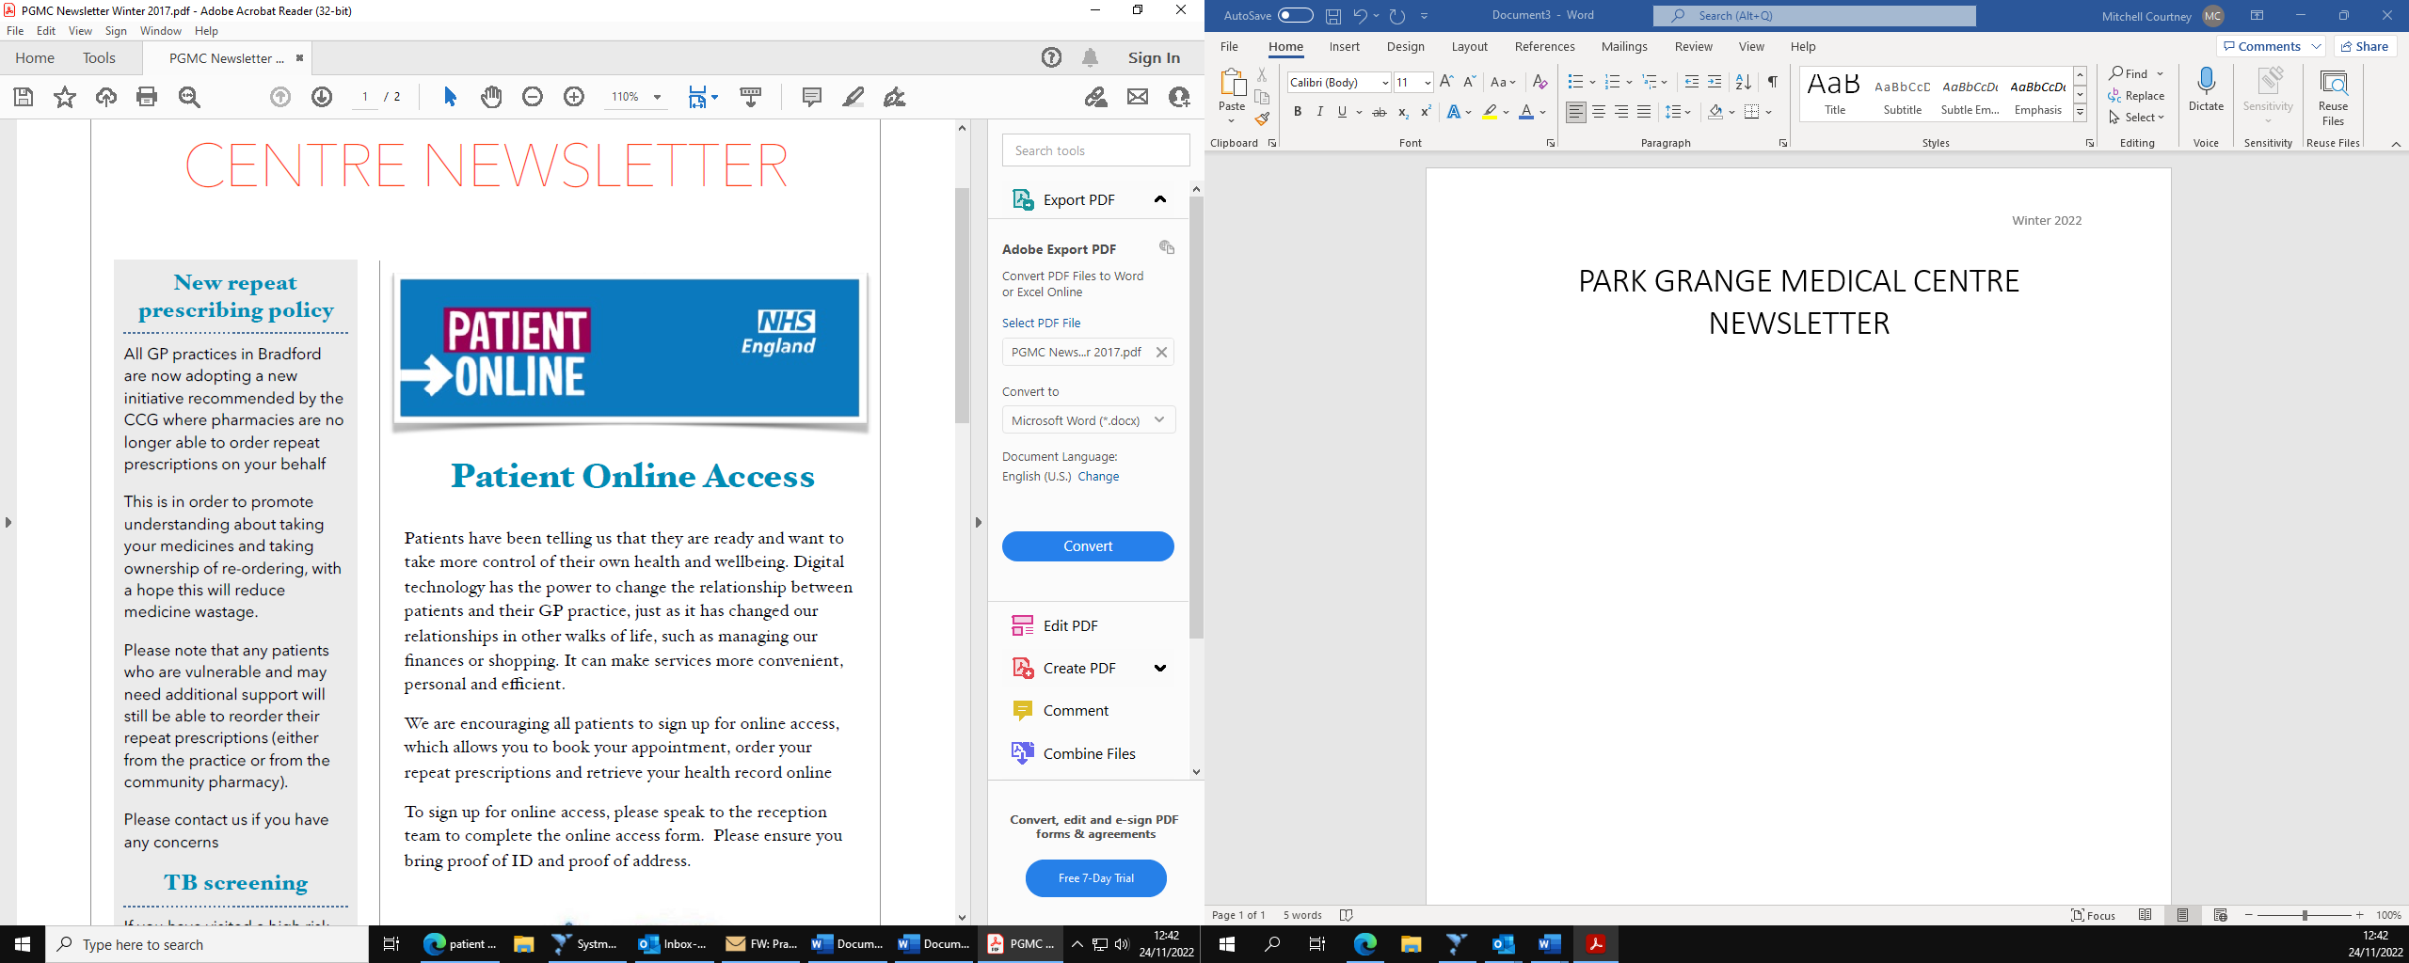

**JOIN THE SURGERY**

**…………………………………..**

Patients can now register using our online link. Join the Surgery is a service that enables new patients to register with our practice. It requires patients to enter the relevant details we need in order for us to register the patient at our practice. Patient boundary for registration covers BD7 patients only.

Click the link below:

<https://www.parkgrangemc.co.uk/pages/New-Patient-Registration>

# **PATCHS**

All GP practices in Bradford have recently adopted a new way to try and make speaking to a clinician easier by introducing the Patches service.

Patients are able to choose from the following options:

* Self-help
* Prescription Requests
* General admin requests
* Sicknote requests

If patients would like advice from a clinician they can complete a short questionnaire and where relevant send a photograph about their symptoms or condition which will be sent directly to the practice.

To access the Patches service please follow the link below:

<https://patchs.ai/practice/parkgrangemedicalcentre>



# **Non-clinical interventions team**

# **Health and Wellbeing Coach**

# **Social Prescriber**

Helen is our Health and Wellbeing Coach. The purpose of Helen’s role is to use health coaching skills to support patients to develop their knowledge, skills and confidence to become active participants in their care, so they are able to reach their own health and wellbeing goals. Helen works alongside our Social Prescriber and Mental Health Practitioner.

In the coming months Helen will be hosting a weekly drop-in centre inside the practice on a Wednesday 10am-12pm. However, your GP / Reception staff can also refer you to the Health and Wellbeing service for an appointment.

Rehana is the Social Prescriber for our practice. The purpose of Rehana’s role is to support patients with various social need. For example, Rehana will be able to support and signpost patients into the right direction for what they may need. Rehana will assess what support patients need, this can be physical, mental, social, and financial. Referring patients who need care and support into a range on local activities. Finding and signposting patients to local community groups and charities for those who may need it. Our Social Prescriber works alongside the Health and Wellbeing coach and the Mental Health Practitioner.

For an appointment with Rehana pleas discuss a referral with a clinician or practice reception staff.



# **Mental Health Practitioner**

As part of a new programme most practices in Bradford now have an inhouse Mental Health Practitioner. Our practice has Craig, who has previous experience in secondary mental health care. Patients can only be referred to Craig Via clinicians, the Health and Wellbeing Coach or the Social Prescriber.

**Cervical Screening:**

Cervical Screening is a service that is regularly available at our practice – it is carried out to help reduce the number of people that may be affected by cervical cancer. This Screening is offered to all people at risk so that any conditions that may develop into invasive cancer are identified and treated as early as possible. Please contact the practice to arrange an appointment.

# **Primary Care Networks**

Our practice is part of a Primary Care Network (PCN), PCN’s are groupings of surgeries who aim to work together to achieve local goals to improve the level of patient care, using PCN’s we can offer a wider level of services as well as different types of staff to support the practice. PCN’s have been used to deliver the Covid-19 Vaccination programme and more recently to offer Enhanced Access Appointments, please see below for more information on this.

# **Enhanced Access Appointments**

As a practice we are now able to offer additional appointments using the new enhanced access appointments, this service is being delivered partially via our PCN, we have a range of appointments on offer, from Cervical Screening and Paediatric blood appointments as well as Paediatric GP appointments.

Appointments are also available ‘Out of hours’ after 18:30 for GP, Nurse, HCA and Physiotherapy.

# **Multi-Generational Home Visits**

Three teams, comprising of Physician Associate, Administrative Staff, and Healthcare Assistant, were established. These teams are conducting community visits to 7-8 families from each practice. The aim of the project is to educate patients on the importance of engaging with the practices and secondary care on cancer screening, immunisation programmes, quality care indicators and well- being for the patients and their families.

# **Wednesday GP Hub Appointments**

GP Hub Doctors appointments are also available at our surgery on Wednesdays. This service allows other GP practices to book their patients with us if they have no slots available in their clinics.

# **Thursday HCA additional HCA Appointments**

Park Grange has additional diabetes check appointments on Thursdays. This check involves the diabetes 9 care processes.

* HBA1c Measurement,
* Blood pressure measurement
* Urine ACR measurement
* Foot surveillance
* Serum creatinine
* Serum cholesterol
* Body mass index
* Smoking status

# **Covid Vaccination**

Covid 19 vaccinations are an important part of protecting yourself if you’re at a higher risk of getting ill from covid 19. These vaccines are offered to top up your protection if you’re eligible. If you are interested in having the Covid 19 vaccination done, please contact the surgery.

# **RSV Vaccination**

The RSV vaccinations are offered to pregnant women and those ages 75 years and over to protect them form a virus called respiratory syncytial virus which can make babies and elderly people very ill. It is recommended for pregnant ladies and elderly people to get it done. If you are interested in having this vaccination done, please get In contact with our surgery so we can arrange a suitable time for you to get the injection.

# **Pneumococcal Vaccination**

These vaccinations are offered in our surgery to help protect patients against the most common type on pneumonia. These vaccinations are eligible for those patients aged 65 years and above. If interested please contact the surgery to arrange a suitable appointment time.

# **Influenza Vaccination**

Our practice offers seasonal vaccinations. Flu can be serious or life threatening.

Our influenza vaccinations are eligible for:

* Everyone ages 65 years and over
* All pregnant women, at any stage of pregnancy
* All children ages 2 and 3 years
* Everybody who resides in a care home
* Everybody who receives carers allowance or are the main carer for a disabled person
* All those living with someone who has lowered immunity due to a disease or treatment
* All frontline health and social workers

If interested , please contact the surgery to arrange an appointment, or alternatively there is a walk in service available for the influenza vaccines.

Now that COVID restrictions are easing off the practice is wanting to restart the PPG programme. This is formed by a group of patients, carers and GP practice staff who meet to discuss practice issues and patient experience to improve the service.

The purpose of PPG is to give patients and practice staff the opportunity to meet and discuss topics of mutual interest.

Currently our practice is actively looking for patients who may want to be a part of this programme- please contact reception to discuss signing up.

Our practice has recently introduced Survey Monkey which is a short survey for patients to give their feedback on practice experience. This feedback is anonymous so patients can give their honest feedback. This is a way of improving practice experience for patients.

If you would like to leave your feedback, please scan the QR code below once completed your survey will be sent directly to the practice.

# **Patient feedback**

# **Patient Participation Group (PPG)**

